The Greatness of Humility

INTRODUCTION
Pirkei Avos, 4:4
Rabbi Levitas of Yavneh said: Be extremely lowly of spirit, for the end of man is worms.

Pirkei Avos, 6:6
Torah is greater than priesthood and kingship, for kingship is acquired with 30 qualities, priesthood is acquired with 24, whereas the Torah is acquired with 48 ways. These are: … (7) humility…

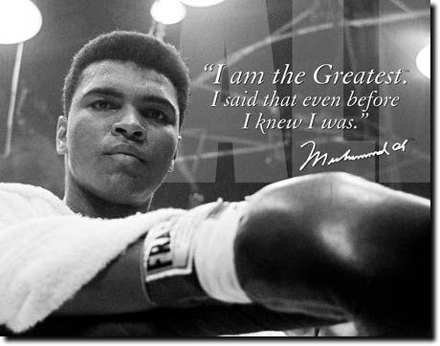

When you’re as great as I am, it’s hard to be humble.
~ Muhammad Ali

#1 Define Humility!
GOOGLE Definition
hum·ble ˈhəmbəl/

Adjective
- Having or showing a modest or low estimate of one's own importance.
Synonyms: meek, deferential, respectful, submissive, diffident, self-effacing, unassertive;
- Of low social, administrative, or political rank.
Synonyms: lowly, working-class, lower-class, poor, undistinguished, mean, modest, ignoble, low-born, plebeian, underprivileged;

Verb
Lower (someone) in dignity or importance. "I knew he had humbled himself to ask for my help" Synonyms: humiliate, abase, demean, lower, degrade, debase; mortify, shame, abash; informal cut down to size, deflate, make eat humble pie, take down a peg or two, settle someone's hash, make eat crow "he had to humble himself to ask for my help."

#2 Question:
What are the advantages and disadvantages of humility?
In personal life and in the business world/workplace?

#3
Maimonides, the Laws of Personal Development, 1:3,4
The two extremes of each quality are not the proper and worthy path for one to follow or train himself in…
The upright path is the middle path of all the qualities known to man. This is the path which is equally distant from the two extremes, not being too close to either side... He should also not be overly miserly, nor should he squander all his money. Rather, he should give charity as he can afford, and lend appropriately to people who need… And likewise for all his other qualities. This, generally speaking, is the way of the wise. Any person whose character traits all fall in the center, midway between the extremes, is considered wise.

Maimonides, the Laws of Personal Development 2:3
There are certain character traits which a person is forbidden to accustom himself in, even in moderation. Rather, he must distance himself to the opposite extreme. One such trait is haughtiness. For the ideal path is not that one be humble alone; he must be lowly of spirit and exceedingly unassuming. Likewise it is said of Moses that he was ‘very humble’ (Numbers 12:3) — not merely ‘humble’. So too did the Sages command us: ‘Be extremely lowly of spirit.’ (Pirkei Avos 4:4)

Question: Why is humility an exception to the rule?

#4
Numbers 12:3
Now this man Moses was more humble that any other person on the face of the earth.

Question:
How could be the biggest leader and prophet of all time be the most humble person?

Didn’t he know about his qualities and character traits?
He took the Jewish nation out of Egypt, fought wars, played the main role in receiving the Torah, and was head of the supreme court?!

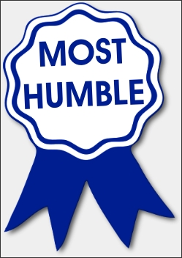

#5
Sotah 49a
“After Rabbi Yehuda died, humility…ceased to exist.”
Rav Yosef disputes the claim, saying, “Don’t say ‘Humility’ – there is still me!”

Question:
How do you understand Rav Yosef’s claim?

#6 Redefine Humility!

#7 Question:
How would you apply these concepts and your findings to your own life and personality?

